Michael Thomann

Date of birth | 9. February 1969
Nationality | Swiss
 | 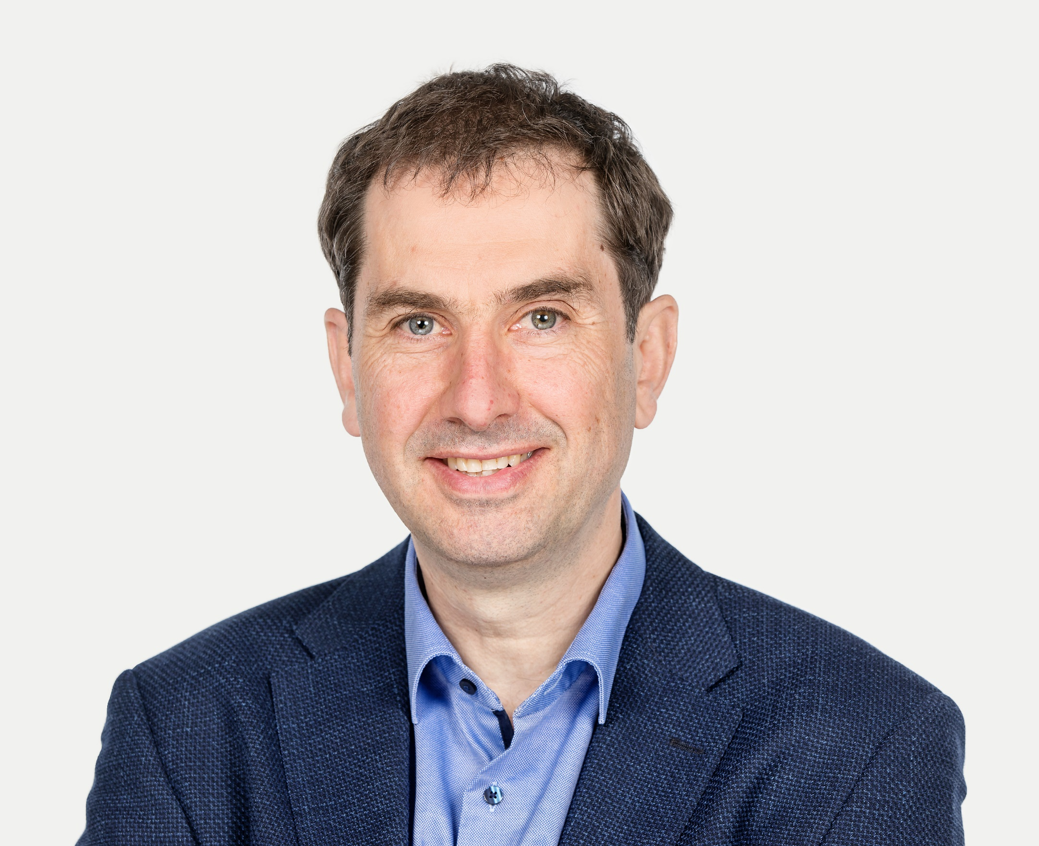
Function | Lecturer and group leader
 | environmental and water technology

Professional experience

02/20 to present | University of Applied Sciences and Arts FHNW, School of Life Sciences, Muttenz, Switzerland  Professor for environmental and water technology
09/05 – 12/19 | HOLINGER AG, Liestal, Switzerland  Head wastewater technology  Deputy head branch Liestal
10/02 – 07/05 | BMG Engineering AG, Schlieren, Switzerland  Project leader industrial wastewater treatment
01/97 – 09/02 | EAWAG, Dübendorf, Switzerland  Research department “Process engineering” Prof. Dr. W. Gujer, Dr. sc. techn. ETH
05/94 – 07/96 | ETH, Zurich, Switzerland  Scientific assistant Institute of Environmental Engineering, Prof. Dr. W. Gujer

Education

2002 | Dr. sc. techn., ETH Zurich, Switzerland
1994 | Dipl. Civil Eng., ETH Zurich, Switzerland
1988 | Matura D, Holbein-Gymnasium, Basel

Professional experience – Full-scale wastewater processes for the elimination of micropollutants

2014 – 2018 | ERZ, Wastewater treatment plant WWTP Zürich-Werdhölzli, Switzerland  Overall project manager + project manager process technology, process unit for the elimina--  tion of organic micropollutants with ozonation + sand filtration
2013 – 2019 | Wastewater treatment plant WWTP Altenrhein, Thal, Switzerland  Overall project manager and project manager process technology, process unit for the elimi-  nation of organic micropollutants with an ozonation and a filtration with granular activated  carbon
2011 – 2014 | Wastewater treatment plant WWTP Neugut, Dübendorf, Switzerland  Overall project manager + project manager process technology, first full-scale ozonation for  the elimination of organic micropollutants in Switzerland
2017 – 2019 | Wastewater treatment plant WWTP Flos, Wetzikon, Switzerland  Overall project manager + project manager process technology, process unit for the elimi-  nation of organic micropollutants with direct dosage of powdered activated carbon in an acti- vated sludge system
Professional experience – Industrial wastewater treatment and offgas treatment

2011 – 2019 | Wastewater treatment plant ARA Rhein AG, Pratteln, Switzerland  Overall project manager + project manager process technology, flotation, upgrade sludge  treatment
2017 – 2019 | DSM Nutritional Products, Sisseln, Switzerland  Project manager, feasibility study aerobic und anaerobic industrial upgrade of the waste-  water treatment plant and offgas treatment, pilot plant study of a high-rate nitrification in  a moving bed reactor
2017 – 2019 | Roche Diagnostic International, Rotkreuz, Switzerland  Project manager, feasibility study ozonation and filtration with granular activated carbon  pharmaceutical wastewater, mass-flow model for effluent concentration prediction,  lab tests for ozonation, fenton’s reagent and activated carbon adsorption
2005 – 2012 | Wastewater treatment plant WWTP Hesperingen, Luxembourg  Project manager process technology, nitrifying+denitrifying moving bed reactor, anaerobic  mesophilic sludge treatment, offgas treatment

Professional experience – R&D-pilot projects for the elimination of micropollutants in WWTP
2016 – 2019 | Wastewater treatment plant WWTP Altenrhein, Thal, Switzerland - Pilotplant  Project manager, semi-industrial pilot plant ozonation and filtration with granular activa  ted carbon, R&D-collaboration of HOLINGER with EAWAG (ecotoxicology) und FHNW  (EU-project nextGen)
2014 – 2016 | Wastewater treatment plant WWTP Neugut, Dübendorf - Pilotplant  Project manager, semi-industrial pilot plant ozonation and filtration with granular activa  ted carbon and biological moving bed reactor, project “RETREAT”, R&D-collaboration of HOLINGER with EAWAG and WWTP Neugut
2012 – 2015 | Wastewater treatment plant WWTP Flos, Wetzikon - Pilotplant  Project manager, full-scale pilot plant for powder activated carbon dosage into an activa  ted sludge system, project “PAK im Belebtschlammsystem” funded by FOEN (Federal  office for the environment) R&D-collaboration of HOLINGER with HSR (Hochschule Rapperswil)
2013 – 2015 | Wastewater treatment plant WWTP Ergolz 1, Sissach - Pilotplant  Project manager, realisation of a full-scale pilot plant for dosage of powdered activated carbon in an existing sand filtration, project „Aktifilt“, R&D collaboration of HOLINGER  with AIB (Amt für industrielle Betriebe), FHNW and EAWAG
2008 – 2010 | Wastewater treatment plant WWTP Vidy, Lausanne - Pilotplant  Project manager, realisation of three full-scale pilot plants – biological treatment with  moving bed reactor, ozonation and ultrafiltration with powdered activated carbon ad-  sorption, project „Micropoll“ funded by FOEN (Federal office for the environment), R&D  collaboration of HOLINGER with STEP de Vidy, EPFL, EAWAG and Triform
2008 – 2009 | Enhanced hospital wastewater treatment, Kantonsspital Baden - Pilotplant  Project manager, semi-industrial pilot plant, membrane bioreactor (MBR) for the en-  hanced treatment of hospital wastewater, EU-Project „Pills”, R&D collaboration of HOLINGER  with EAWAG and Kantonsspital Baden

Professional experience – expert studies

2020 | Technical guideline (VSA, Glattbrugg) – Analytikdaten in ARA  Project manager, expert study, guideline for data quality control and uncertainty analysis  for wastewater treatment plant data
2018 | FOEN (Federal office for the environment), Bern  Project manager, expert study, development of a new infrastructure cost model for the  realization of the elimination of micropollutants in Swiss wastewater treatment plants
2015 | Technical guideline (VSA, Glattbrugg) - Empfehlung Dimensionierungswassermenge und Redundanzen von Stufen zur Elimination von Mikroverunreinigungen  Project manager, expert study, Design guideline for upgrade of wastewater treatment  plants with organic micropollutant elimination processes
2012 | FOEN (Federal office for the environment), Bern  Expert, review of the project report DIMES (Diffuse emissions of micropolluntants from  settlements

Commissions

IWA  VSA | Member International Water Association  Member VSA-Plattform „Mikropoll“  Lectures “Anaerobe Schlammbehandlung” in VSA-education since 2011  (Verband Schweizer Abwasserfachleute)

Languages

German | Mother tongue
English | Fluently, CAE
French | Intermediate
Spanish | Intermediate

IT Knowledge

MS-Office | Word, Excel, Powerpoint
Simulation | AQUASIM, ASIM, Matlab, Simulink
Various Software | S-Plus, LATEX, Matlab Statistic Toolbox

